Project Design Phase-II
Technology Stack (Architecture & Stack)

Date | 4 April 2026
Team ID | Team 1
Project Name | Automating Data Import and Relationship Mapping using Import Sets and Dot Walking
Maximum Marks | 4 Marks

Technical Architecture:
Following is the Technical Architecture DIagram of our project
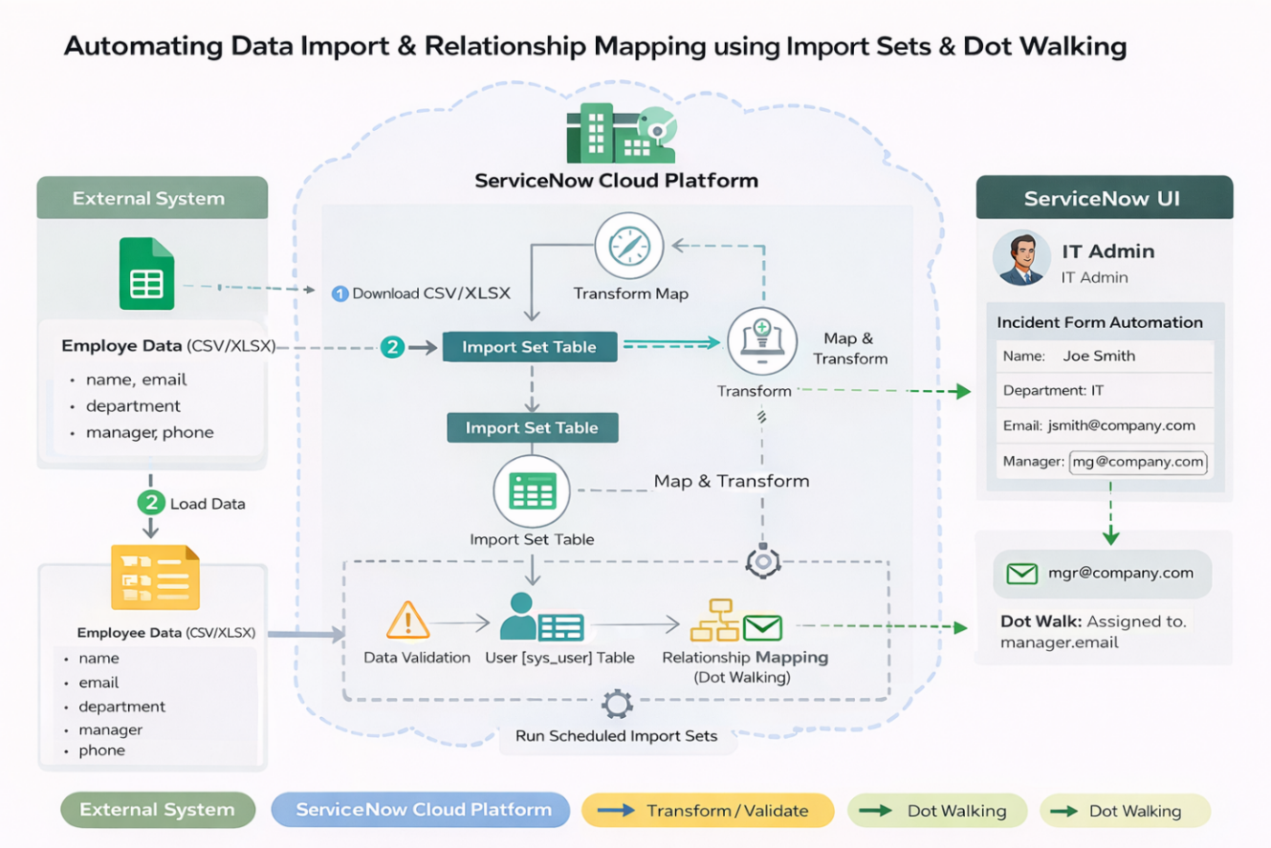
\0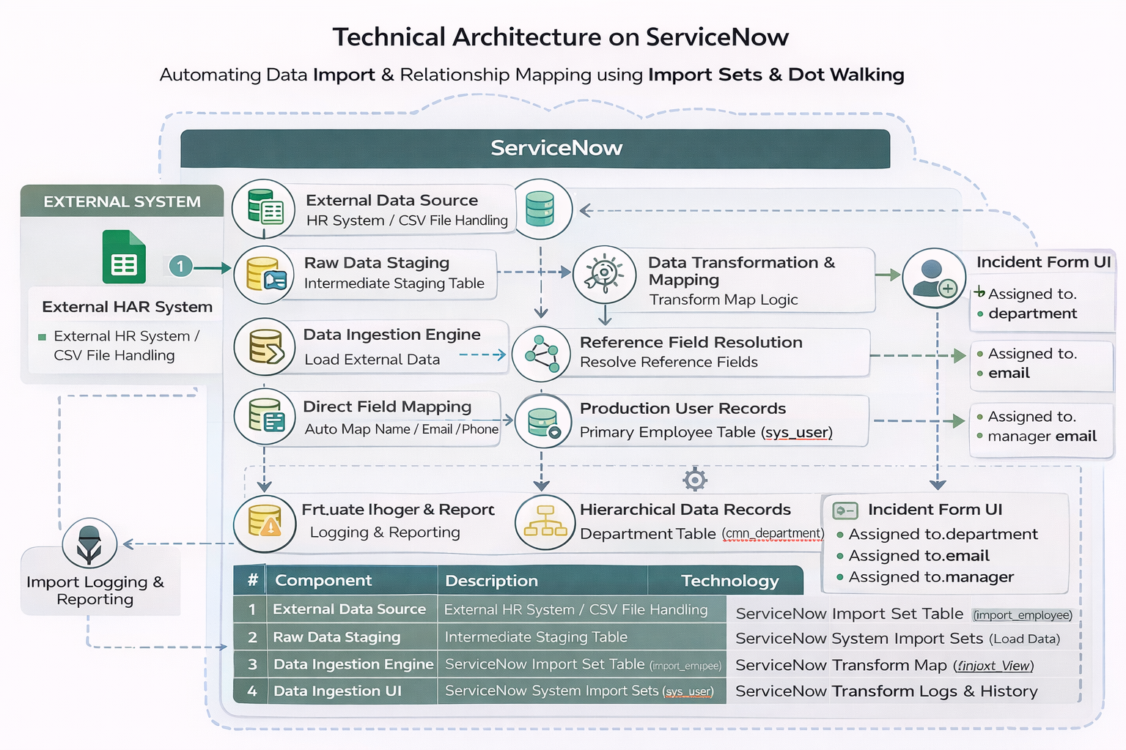

Table-1: Components & Technologies:
S.No. | Component | Description | Technology
1. | External Data Source | Configuration to securely ingest the initial list of new employee details. | External HR System / CSV File Handling
2. | Raw Data Staging | An intermediate, transient storage table used to hold raw data from the CSV file. | ServiceNow Import Set Table (import_employee)
3. | Data Ingestion Engine | Platform mechanism used to load external data into the staging table. | ServiceNow System Import Sets (Load Data)
4. | Data Transformation & Mapping | Core logical component that defines how raw staging data is converted and mapped to target production records. | ServiceNow Transform Map
5. | Direct Field Mapping | Automated process to link simple text fields like Name, Email, and Phone. | ServiceNow Auto Map
6. | Reference Field Resolution | Logic to look up and link existing production records for complex relationships (Department, Manager). | ServiceNow Mapping Assist
7. | Production User Records | The platform’s primary, persistent table for active employee profiles. | ServiceNow User Table (sys_user)
8. | Hierarchical Data Records | The production table defining the organization's department structure, required for valid relationship lookups. | ServiceNow Department Table (cmn_department)
9. | Incident Form UI | The user interface view of the Incident table, which is configured to display cross-referenced user details. | ServiceNow Form Design (Incident default view)
10. | Dynamic UI Binding | Platform-native, zero-code logic used to expose related data on the Incident form automatically. | ServiceNow Dot-Walking (Assigned to.department, Assigned to.email)
11. | Import Logging & Reporting | The system tool used to track the success or failure of each automated data load batch. | ServiceNow Transform Logs & History

Table-2: Application Characteristics:
S.No | Characteristics | Description | Technology
- 1. | Open-Source Frameworks | No external open-source frameworks are directly utilized for this configuration. The solution relies entirely on built-in, out-of-the-box platform capabilities. | ServiceNow Platform Native Features (Proprietary)
- 2. | Security Implementations | Access to upload data and configure Transform Maps is strictly limited via Role-Based Access Control (RBAC). Visibility of the dot-walked fields on the Incident form is governed by existing platform Access Control Lists (ACLs). | ServiceNow ACLs, RBAC (admin, import_admin roles)
- 3. | Scalable Architecture | The solution leverages ServiceNow's multi-instance cloud architecture. The Transform Engine uses an asynchronous staging table model, allowing it to scale effortlessly from processing 10 records to 10,000 records without blocking platform operations. | ServiceNow Multi-Instance Architecture, Async Import Sets
- 4. | Availability | The data pipeline and modified Incident forms inherit the enterprise-grade High Availability (HA) of the core ServiceNow platform, ensuring the feature is always online. | ServiceNow Advanced High Availability (AHA) Cloud Infrastructure
- 5. | Performance | Import processing uses staging (import_employee) to prevent database locking on the live sys_user table. On the UI side, dot-walking is processed server-side, entirely avoiding the need for slow, performance-heavy client-side scripting (like GlideAjax). | Transform Map Engine, Server-side UI Rendering (Dot-walking)

